Educational Media Order Form – Articles
Please print clearly
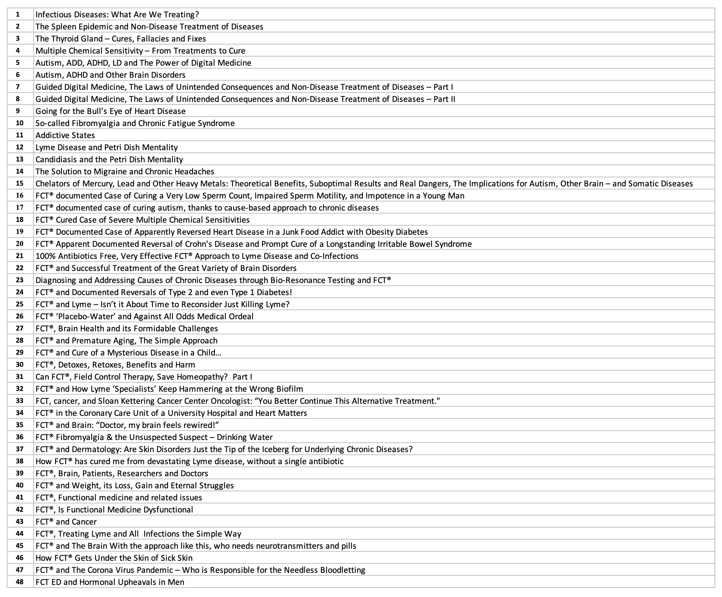
Articles:
Please indicate, below, the corresponding number(s) of each of the article(s) you would like to order, from the list above.
SAVE 70% when you purchase the FULL SET of 48 articles for $144.00
(for hard copies, $160 + S/H).
- I would like to save 70% and order the FULL SET of 48 articles for $144.00

- I would like to order the following article(s) at $10 each:

#_____, #_____,#_____, #_____, #_____,#_____,#_____, #_____,#_____,#_____, #_____,#_____,#_____, #_____,#_____
Subtotal: _______________________
To complete your order, please fill out this order form, and fax, scan/email, or mail both pages back to us. Thank you.

SYY Integrated Health Systems, Ltd.
37 King Street, Chappaqua, New York 10514 Phone: (914) 861-9161 Fax: (914) 861-9160
Email: info@yurkovsky.com
Website: www.yurkovsky.com

The Science of Medicine Teaching Company

Order Form
Please print clearly
Shipping Address:
Name: _______________________________________ Degree: ____________________________
Address: _________________________________________________________________________________
City:________________________________________ State: ____________ Zip: ______________

Billing Address (if different from shipping):
Name: _______________________________________
Address: ________________________________________________________________________________
City: ________________________________________ State: _____________ Zip: ___________________

Contact Information:
Phone: ____________________________________ Fax: ___________________________________

Email: _________________________________________________________

Payment:
_____Check/Money Order (Made out to “SYY HIS, Ltd.”)
Credit Card: _____Visa _____M/C _____Amex
Card Number: _________________________________________________________________________
Exp: __________ CVV: _______

Print Name: __________________________________________

Signature: ____________________________________________ Date: ________________________

