How FCT® has cured me from devastating Lyme disease, without a single antibiotic
In December of 2010 I developed swollen painful joints, fatigue, headaches, brain fog and was diagnosed with Lyme disease, through a blood test. After receiving for a month an oral antibiotic, Doxycline, I felt only partial relief and have developed chemical sensitivities. I refused intravenous antibiotics, and, instead, took herbal Lyme protocol and acupuncture treatments. These helped a little, but when I was having my periods all of the symptoms would return with, even, worse headaches. I went to see Savely Yurkovsky MD, in Chappaqua, New York, who practices FCT and who, through his bio-resonance testing has confirmed that I still had Lyme infection. But the main problem, he said, was not Lyme, but that my immune system couldn’t fight it due to mercury and electromagnetic radiation poisonings. I did have mercury filings, in the past. The best way to treat Lyme, he said, was not through antibiotics or alternative pills and electrocutions to kill chronic Lyme infection, because this is not possible for as long as the immune system remains poisoned and unable to control an infection. Besides, he said, that all of these treatments to kill Lyme make it only worse, because this bacteria has an uncanny ability to mutate and turns into, even, worse, more aggressive forms. That is why the goal was to turn my own immune system, by depoisoning and strengthening its organs, into the strongest antibiotic against Lyme. This sounded too good to be true, that some homeopathic water drops would do that strong antibiotics and herbs couldn’t, but to my surprise and joy, following just two treatments, with these drops for mercury, Lyme, electromagnetic radiation and strengthening my immune and other weak organs, as well as acquiring EMF protective devices, Memon, all of my Lyme symptoms were gone for almost four years. During this time I stopped health maintenance visits, which Dr. Yurkovsky recommended, and likely because of that I got re-infected with Lyme, in December of 2015. This time around it made me much sicker where I became disabled and quit my job. I had many, and severe symptoms: migraine headaches, brain fog, poor memory and concentration, anxiety and panic attacks, heart palpitations, imbalance, popping in the ears, jaw and multiple joints pain, allergies to foods and chemicals, gastrointestinal symptoms with mucus in the bowels, shortness of breath, blurry vision, severe fatigue, and extreme electromagnetic sensitivity where computer and even shopping, under fluorescent lights, made me feel like I was dissolving and dying. I tried several alternative treatments, including those to desensitize me from allergic foods and chemicals, which used applied kinesiology and Bio-set, but some symptoms would improve while others, worsen, and after more than a year I realized that I was getting nowhere. I traveled back to Dr. Yurkovsky, in February of 2016. Based on his bio-resonance testing, he told me that I must have gotten re-poisoned with mercury and other toxic metals either from seafood or other sources which poisoned and suppressed my immune and other organs, leading to many other infections, besides Lyme. These were: Babesia, parasites, herpes and flu viruses, candidiasis, molds. All of these were all over my body, including the brain, and on top of it were attracting, like magnets, electromagnetic radiation, from all over. He told me to stay away from electronics, stop all of the supplements for Lyme, because poisoned and infected body has unpredictable reactions to any treatment, and these won’t get through the poisons, anyway. I went on his homeopathic drops, again, to de-poison, disinfect and revitalize, virtually, all of my organs from head to toe. Fortunately, and, again, I began making progress immediately, with each treatment. My mother said,: “Helen, your voice is different, it is more coherent”. I, literally felt something was draining, pouring out from my brain into my ears and down my spine for weeks, after I took just a drop of a remedy for mutated Lyme. I had my life back and I was almost a different person. After other drops, I felt things coming out of my head, too. After Head I + Metals remedy, mucus was pouring out of my sinuses and caustic tasting saliva from my mouth, jaw ached with a liquid coming out of my gums, for days. All in all, my head became so much better that, even, electronics and fluorescent lights stopped bothering me that much, which was a proof that I was not crazy, as my conventional doctor thought. My mental clarity became almost normal, it hasn’t been like that for thirty years and, especially, last five years. No headaches for months. My head and skin became remarkably better and, completely different, too. Wow! It became much smoother, with all the bumps, scales and redness, of thirty years, gone. I always thought it was allergies. People have said, “You look fabulous”. Even though Dr. Yurkovsky’s bio-resonance testing kept finding mercury and toxic metals in my body, even after I discontinued all seafood, that he said was bothering him, but since May of 2017, after receiving the last remedy for Lyme, I never had Lyme symptoms or having to take the remedy again and consider myself cured from it.
Later on, Dr. Yurkovsky has solved my mercury and toxic metal re-poisoning mystery, which were causing me periodic stomach upset, through testing by bio-resonance my spring water and Himalayan sea salt. Interestingly, internet has confirmed that this salt does contain mercury and that, many spring waters are, often, contaminated with toxic metals. I’ve been looking to return to work, for quite a while by now, and all I can say is that FCT has saved my life, as I stated the same on YouTube, too.
Helen Baldwin
helendaybaldwin@gmail.com

About the Author
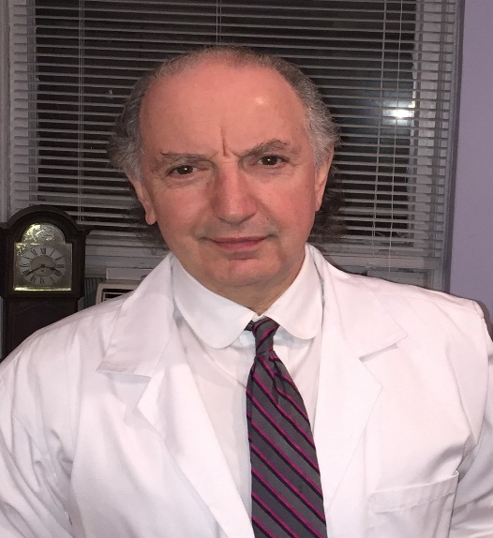
Savely Yurkovsky, MD, a pediatrician, internist and cardiologist, has evolved a novel medical model that interfaces important knowledge from biology, medicine, toxicology and physics. Its primary focus is on the most important aspect of chronic diseases – its causes – along with the most effective diagnostic and therapeutic means to address these. This has transformed the often-imprecise medical interventions into a far more effective, exact and predictable science. He has founded a teaching organization, “SYY Integrated Health Systems, Ltd.,” which provides training in this medical system under the concept of FCT®, Field Control Therapy. This concept as medicine of the future was suggested by Professor Emeritus, of Materials Science at Stanford University, William A Tiller, PhD. He has presented it at many professional symposia in both the U.S. and Europe, including the annual Bio-terrorism 2005 conference: “Unified Science & Technology for Reducing Biological Threats & Countering Terrorism” with affiliation to the Homeland Security Office, and Harvard Medical School, among others. Dr. Yurkovsky has been nominated for the prestigious Bravewell Leadership Award for “significant contributions to the field of medicine” and “compelling vision for the future of medicine,” in 2005. He has authored numerous articles and the book, “The Power of Digital Medicine” that was endorsed by prominent scientists from MIT, Columbia and Stanford Universities and contributed a chapter on homeopathy to the textbook of Integrative Gastroenterology edited by the Chief of Integrative Gastroenterology department at Johns Hopkins University medical school, Gerard Mullin, MD. Dr. Yurkovsky maintains a private practice with a cause-based approach to diseases, covering these from pediatrics to geriatrics, located in Chappaqua, New York.

